# DataBytes/DiscountMate Conventions while using Trello board

Use the correct labels to distinguish the teams:

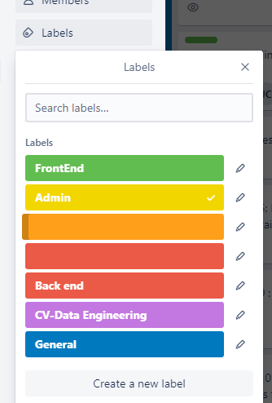

When adding a new card Use the next ticket number as identification for the new card. Do not forget to update the Next ticket# number to the next consecutive number.

Eg. If the current one says DB-P1-PM1-T-13:

Use DB-P1-PM1-T-13: in your new card and update the Next ticket# card to DB-P1-PM1-T-14, so that next person knows the next ticket number to be used.

Use your card numbers to reference in documentation including in GitHub commits.

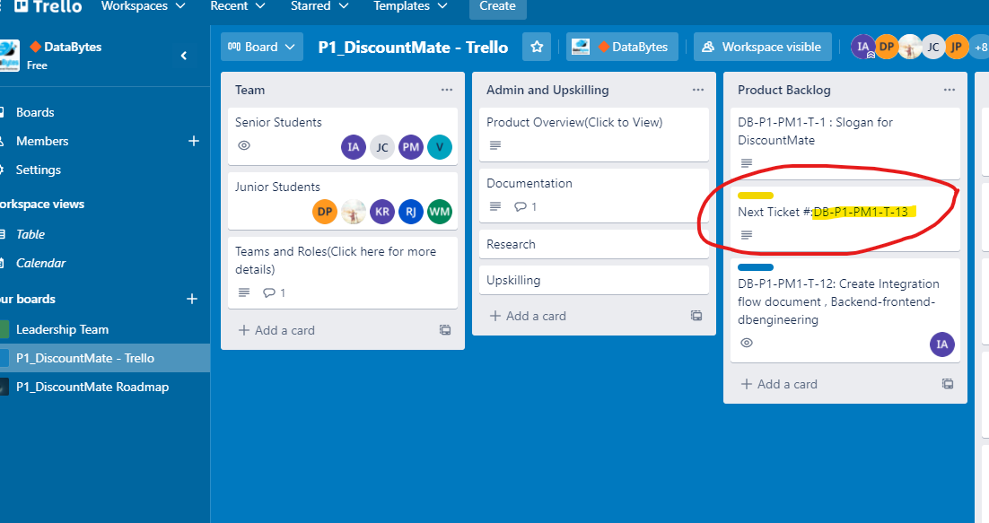

List all of the pending tasks, working in progress and completed tasks in appropriate list in Trello.

If a task needs to be reviewed you can add the card task to review list and let person responsible know.

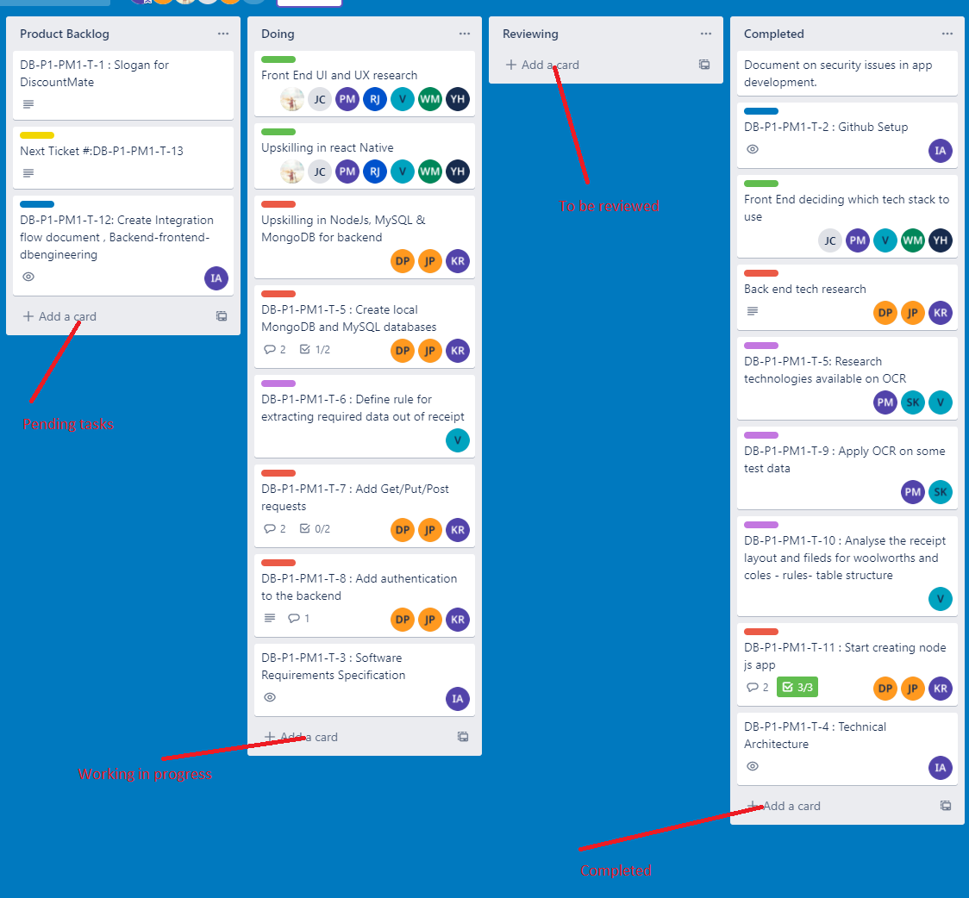

Show/Link/Reference all your Documentation/Research/Upskilling under the Admin and Upskilling List

